KALICHARAN SHILPACHARY

Principal Software Engineer / Project Lead / AI-ML Engineer

+91-9449459091(Bangalore) | hcs.kalicharan@gmail.com | https://www.linkedin.com/in/kalicharan-s/
Profile Summary:
Principal Software Engineer with 15 years of experience in software development, test automation, and enterprise-scale AI solutions. I specialize in building Generative AI–powered productivity frameworks that make global support teams faster, smarter, and more consistent. My expertise spans LLM integration, RAG pipelines, Agentic AI, and API engineering, with a proven record of turning cutting-edge AI into practical, production-ready tools. At Oracle, I’ve led the design of context-aware summarization, orchestration, and evaluation platforms that reduced manual effort by 70% and established reusable frameworks for future AI adoption. Skilled in Agile delivery, global collaboration, and architecting scalable ML/LLM systems, I bring a unique blend of technical depth, architectural vision, and a drive to amplify productivity through AI.
Work Experience:

Oracle India Pvt. Ltd, Bangalore, India
>> May 2018 to Present
>> As Principal Member of Technical Staff and Project Lead.

Huawei Technologies India Pvt. Ltd, Bangalore, India
>> 8 years, March 2010 – May 2018
>> As Senior Software Engineer, Test delivery lead
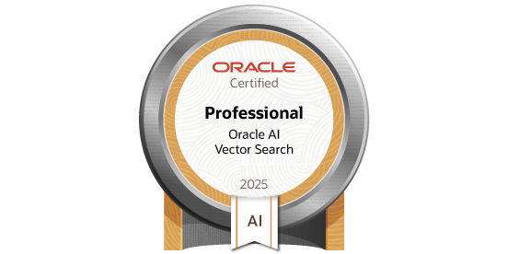
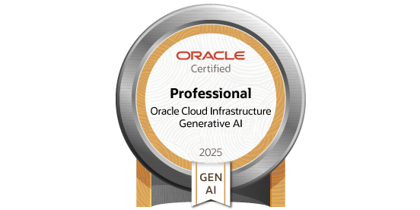
Certifications:
Oracle AI Vector Search Certified Professional
Issue by Oracle
Oracle Cloud Infrastructure 2025 Certified Generative AI Professional
Issue by Oracle

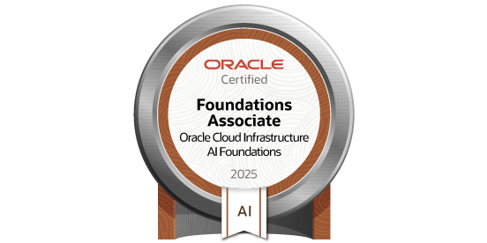
Oracle Cloud Infrastructure 2025 Certified AI Foundations Associate
Issue by Oracle


Certified SAFe® 4 Scrum Master
Issued by Scaled Agile Inc [Expired on 8 Dec 2021]


Certified SAFe® 4 Practitioner
Issued by Scaled Agile Inc [Expired on 19 Mar 2020]
Skills / Technologies:
Generative & Agentic AI: Large Language Models (Cohere, LLaMA, etc.), Retrieval-Augmented Generation (RAG) Pipelines, LLM-based Agents, AI Orchestration, Prompt Engineering & Evaluation, Agentic AI
Frameworks & Libraries: HuggingFace Transformers, Scikit-learn, Pandas

Programming &
API Development: Python, Flask, FastAPI, API Development & Integration with LLMs
Automation & Evaluation: Pytest Automation, Response Evaluation (BLEU, BERTScore), Grafana, Confluence Databases & Infrastructure: Git, Redis, SQL/NoSQL Databases, Docker, Kubernetes, Jenkins (CI/CD), Grafana Agile Methodologies: Scrum, Sprint Planning, Jira, Epics → Features → Stories

Projects:

Agentic AI – Consolidated Support Tool Orchestration (In-progress, Post-POC stage)

Role: Agentic AI Orchestration and Technical Implementation
The Agentic AI initiative aimed to unify multiple AI-powered productivity tools — including End of Shift Note Generation, SR Summarization, and Ask GenAI — into a single user interface. Instead of requiring users to choose a tool manually, the system leveraged user interactive prompts to dynamically route queries to the most suitable backend service.

Key Responsibilities:
- Contributed to the post-POC implementation phase, working on the orchestration layer to route user prompts across End of Shift Notes, SR Summarization, and Ask GenAI.
- Assisted in extending the OneSearch UI to support a unified entry point for productivity tools.
- Implemented initial decision logic to interpret query intent and map it to the right tool.

Early Outcomes / Contributions:
- Established a foundation for orchestration, validating feasibility of prompt-driven tool selection.
- Reduced duplication by demonstrating how disparate tools could be consolidated under one entry point.
- Influenced future architectural direction for Agentic AI capabilities in Support workflows.

Ask GenAI – Hybrid RAG Implementation

Role: Lead Engineer – Generative AI (Hybrid RAG, Evaluation & Optimization)
The Ask GenAI feature provided internal Engineering staff with a conversational interface to query Oracle’s knowledge base and product documentation. To ensure more accurate and context-rich responses, a hybrid Retrieval-Augmented Generation (RAG) approach was implemented, combining vector search with curated keyword search over internal content repositories. This enabled GenAI to provide factually grounded answers while maintaining flexibility for complex queries.

Key Responsibilities:
- Involved in the implementation of the hybrid RAG pipeline, blending vector embeddings (semantic search) with keyword retrieval to maximize coverage and accuracy.
- Integrated retrieval components with the LLM orchestration API to ensure contextually relevant prompt construction.
- Developed evaluation pipelines to measure recall, precision, and factual accuracy of responses, using BERTScore and domain-specific heuristics.
- Optimized retrieval performance for large-scale document sets, ensuring low-latency responses for interactive user queries.

Outcomes:
- Improved response accuracy and factual grounding, reducing hallucinations in support-related answers.
- Worked towards efficient, large-scale retrieval of documents while maintaining interactive response times.
- Established validation benchmarks that became part of the QA process for future iterations of Ask GenAI.
- Increased trust and adoption of Ask GenAI within Oracle Support by ensuring consistent and verifiable outputs.

End of Shift Notes generation – Context-Aware (Non-Document RAG)

Role: Architect and Lead Engineer(end to end)
The End of Shift (EoS) Note Generation feature provided ‘Support Engineers’ with an GenAI-powered assistant that automatically generated structured summaries for running Service requests from their Shift. By leveraging LLMs with context injection of structured ticketing data, the solution reduced manual effort, improved accuracy, and ensured consistent reporting standards across global support teams.

Key Responsibilities:
- Designed and implemented the end-to-end architecture for LLM-powered note generation, including API interfaces, data pipelines, and prompt engineering workflows.
- Built a lightweight retrieval + context integration pipeline that injected Service Request data (activities and customer updates) into the LLM prompt to generate factually aligned, concise summaries.
- Developed reusable Python APIs that standardized LLM calls, enabling modular integration across other productivity features.

- Led validation strategy by defining metrics (BLEU, BERTScore) and building an automated Pytest-based evaluation
framework for model responses.
- Partnered with Support Engineers to capture requirements, refine prompts, and iterate on outputs to ensure adoption and usability.

Outcomes:
- Reduced manual note preparation time for Support Engineers by 70%, freeing them to focus on higher-value customer interactions.
- Improved accuracy and consistency of shift summaries across teams, resulting in clearer handovers and reduced duplicate effort.
- Established a reusable API layer for LLM integration, accelerating delivery of future AI productivity features.
- Boosted adoption of automation in support workflows, leading to higher team satisfaction and measurable productivity gains.

Service Request (SR) Summarisation – Context-Aware (Non-Document RAG)

Role: Architect and Lead Engineer(end to end)
The SR Summarization feature enabled Support Engineers, Managers, and Executives to quickly gauge the status of Service Requests by generating concise, role-targeted summaries using LLMs. The solution was particularly impactful for long-running SRs, reducing the need to navigate extensive ticket histories. Integration with the OneSearch (LLM) UI allowed users to issue Service ticket queries with configurable time frames, ensuring timezone-aware responses consistent with the user’s location.

Key Responsibilities:
- Designed the summarization pipeline to generate context-aware summaries of Service Requests tailored to different roles (Support Engineer, Manager, Executive).
- Implemented support for timeframe-based queries so users could request summaries for specific intervals (e.g., last week, last month).
- Developed a timezone-aware query handler, ensuring that responses matched the timezone of the querying user via OneSearch.
- Built and exposed APIs that could be reused across different support productivity features for LLM-driven summarization.
- Collaborated with management stakeholders to refine summary structures that highlighted escalation risks, progress, and customer impact.

Outcomes:
- Enabled management to quickly assess SR health, reducing the time to identify blockers and escalations.
- Provided significant efficiency gains for long-running SRs, minimizing the need to review lengthy case histories.
- Delivered flexible summarization with timeframe filters, empowering teams to focus only on relevant updates.
- Achieved consistent timezone alignment across global teams, improving clarity of handovers and reducing misunderstandings.
- Established a re-usable summarization service, accelerating development of additional LLM-based productivity tools.

LLM Response Evaluation Dashboard – BLEU/BERT Metrics Pipeline

Role: Architect and Lead Engineer(end to end)
To measure the quality and reliability of LLM-generated outputs, a metrics pipeline was built to compute BLEU and BERT scores for selected use cases. The evaluation targeted two high-impact features: End of Shift Note Generation and Knowledge Management Document Generation (from SRs). For each case, LLM outputs were mapped to human-authored references, and scores were aggregated into a Grafana dashboard for monitoring quality trends.

Key Responsibilities:
- Implemented a Kubernetes CronJob pipeline that ran weekly to identify candidate records (EoS notes and KM documents) with logged human references.
- Built automated workflows to map LLM-generated outputs with reference content:
  - For KM documents → mapped generated doc content to the final approved KM document.
  - For End of Shift notes → mapped generated summary to the manually logged engineer note.
- Integrated BLEU and BERTScore evaluation, ensuring both lexical overlap and semantic similarity were captured.

- Automated score aggregation and pushed results into Grafana dashboards, with visualizations bucketed as per response
quality.

Outcomes:
- Provided objective, quantifiable quality tracking of LLM responses, enabling data-driven improvements.
- Reduced reliance on subjective human evaluation by creating a repeatable and scalable evaluation pipeline.
- Enabled leadership to monitor LLM performance trends over time through Grafana dashboards.
- Established a reusable evaluation framework applicable to future LLM-driven features beyond EoS and KM generation.

ML Projects (Pre-LLM Work) - Service Request(SR) CLASSIFICATION
Developed a machine learning model to classify Service Requests (SRs) into Consultative (questions) or Problem (issues/errors) categories. The model leveraged SR metadata and textual descriptions to improve triage accuracy and reduce turnaround time for consultative SRs, which were historically overshadowed by problem SRs.

Key Responsibilities:
- Engineered features from SR fields including summary, problem description, category/sub-category, component, severity.
- Built and tested multiple ML algorithms, ultimately selecting XGBoost based on superior F1 performance on a held-out validation dataset.
- Designed a text processing pipeline using unigrams, bigrams, and trigrams with TF-IDF weighting; applied class-specific boosting to handle class imbalance.
- Conducted multiple iterations of model tuning to maximize class discrimination, achieving strong generalization across multiple product lines.

Outcomes:
- Achieved significant improvements in SR triage efficiency, enabling faster handling of consultative queries (previously buried within ~85% problem SR volume).
- Reduced manual redirection effort, saving support engineers substantial time in SR classification.
- Demonstrated cross-product applicability, with a model trained on one product set generalizing well to others.
- This model was integrated with the Oracle Support portal to automatically label SRs at creation time.

(Pre-ML Engineering Work)

Oracle Public Cloud Services Domain
Project: Oracle Hybrid SaaS Manager- Hybrid SaaS is an Oracle developed & managed PaaS-SaaS solution.
Role: DevOps, Release and Quality management
  - Hybrid SKU Provisioning in Legacy and OCI
  - Quality improvement using automated build, test and release management. Managing quality reports and issues, helping teams to resolve critical issues
  - Supporting respective service teams for Hybrid SKU validations
  - Involved in verification of Router Functionality Validation and Disaster Recovery Solution for Hybrid Pods
  - Maintenance of E2E Automation of HSM CI/CD and related HSM down Automation Technologies: Kubernetes (OKE), Docker, GIT, Python, Java, JavaScript, Cloud Services (IaaS, PaaS, SaaS), JIRA, Jenkins,
Linux, DevOps, REST, BDD.

Telecommunication VAS Domain
Project: 1. Huawei – CRBT (Caller Ring Back Tone) / USDP (Universal Service Development Platform)
- Huawei – Service Delivery Platform
- Huawei – Global Service Delivery Platform (OPENNESS) Technologies: SOAP UI, Oracle Database 11g, LDAP, USSD, SMS, Python, Web services
Education:

BACHELOR OF ENGINEERING
AT VISVESVARAYA TECHNOLOGICAL UNIVERSITY, INDIA
Course: Electronics and Communication

